MANGOCHI CATHOLIC DIOCESE MOCK EXAMINATIONS

2025 MALAWI SCHOOL CERTIFICATE OF EDUCATION
GEOGRAPHY
Subject Number: M073/I
Wednesday, 21 May 2025 Time Allowed: 2hrs 30 mins
8:00 - 10:30 am
PAPER I
(100 marks)

MAP READING AND PHYSICAL GEOGRAPHY

Instructions
Question number | Tick if answered | Do not write in these columns
1
2
3
4
5
- This paper contains 9 printed pages. Please check.
- This paper has five questions. Answer the questions in the spaces provided.
- This paper has two sections, A and B.
- Section A comprises of three questions and candidates must answer all the three questions.
- Section B comprises of two questions and candidates must answer one question only.
- Write your Examination number on top of the question paper.
- In the table provided on this page, tick against the question numbers you have answered.

© 2025 MH DIOCESE Turn over

Section A (75 marks)
- Study the 1:50,000 map extract of Lilongwe sheet number 1433 B and answer the questions that follow:
- (i) Find the six-figure grid reference for the borehole BH D 96.
________________________________________________________(1 mark)

(ii) Identify the feature found at grid reference 684342.
_______________________________________________________ (1 mark)
(iii) From which direction is Chimakuwi River on the north western
corner of the map flowing.
________________________________________________________ (1 mark)
- (i) Describe the drainage pattern shown by rivers between eastings 69
and 70 and between northings 33 and 34.
_________________________________________________________ (1 mark)
(ii) Describe the riverine feature being displayed by the river between
eastings 63 and 64and between northings 30 and 31.
__________________________________________________________ (2 marks)
(iii) Give the cause of the riverine feature in 1b (ii).
_____________________________________________________________________________________________________________________________ (2 marks)
- (i) Identify the settlement pattern found in four figure grid reference 7434.
_______________________________________________________ (1 mark)
(ii) Describe two factors that have promoted development of the settlement pattern in 1. c. (i). _____________________________________________________________________________________________________________________________ (4 marks)
- Calculate the area of Dzalanyama Forest Reserve.

(5 marks)
- Give any two occupations of people living in the area shown on the map.
_____________________________________________________________________________________________________________________________ (2 marks)
- Draw a cross-section along northing 38 between eastings 70 and 75 on the graph paper provided. On the cross-section show the tertiary road.
Take 1 cm to represent 50ft.

continued/…


(2 marks)

(5 marks)
2.a. (i) Give any two examples of ocean plates.
___________________________________________________________________________________________________________________________________ (2 marks)
(ii) Explain why convergent plate boundaries are known as destructive plate
Boundaries.
_______________________________________________________________________________________________________________________________________________ (2 marks)

continued/…
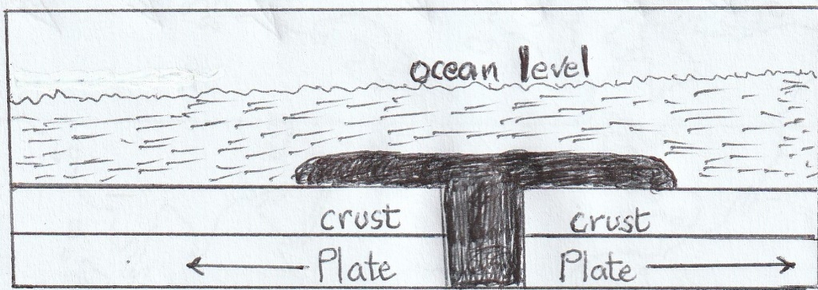
(iii) Figure 1 is a feature formed along a plate boundary. Use it to answer the questions that follow.

RIDGE

Figure 1
- Identify the feature in the figure.
_________________________________________________________ (1 mark)
- Explain how the feature is formed.
___________________________________________________________________________________________________________________________________________________________________________________________________________________________________________________________ (4 marks)
- Give one example of the feature shown in figure.
_________________________________________________________ (1 mark)
b. (i) Explain how metamorphic rocks are formed.
__________________________________________________________________
__________________________________________________________________
__________________________________________________________(3 marks)
(ii) Give any two examples of volcanic rocks.
__________________________________________________________________
_________________________________________________________(2 marks)
(iii) Why do sedimentary rocks contain layers?
___________________________________________________________________
__________________________________________________________ (2 marks)
c. (i) State any two negative influence of Fold Mountains.
_________________________________________________________________
_________________________________________________________________
_________________________________________________________ (2 marks)
(ii) Give any two examples fold mountain _______________________________________________________________________________________________________________________________ (2 marks)
continued/…
d. Figure 2 is a riverine feature. Use it to answer questions that follow.
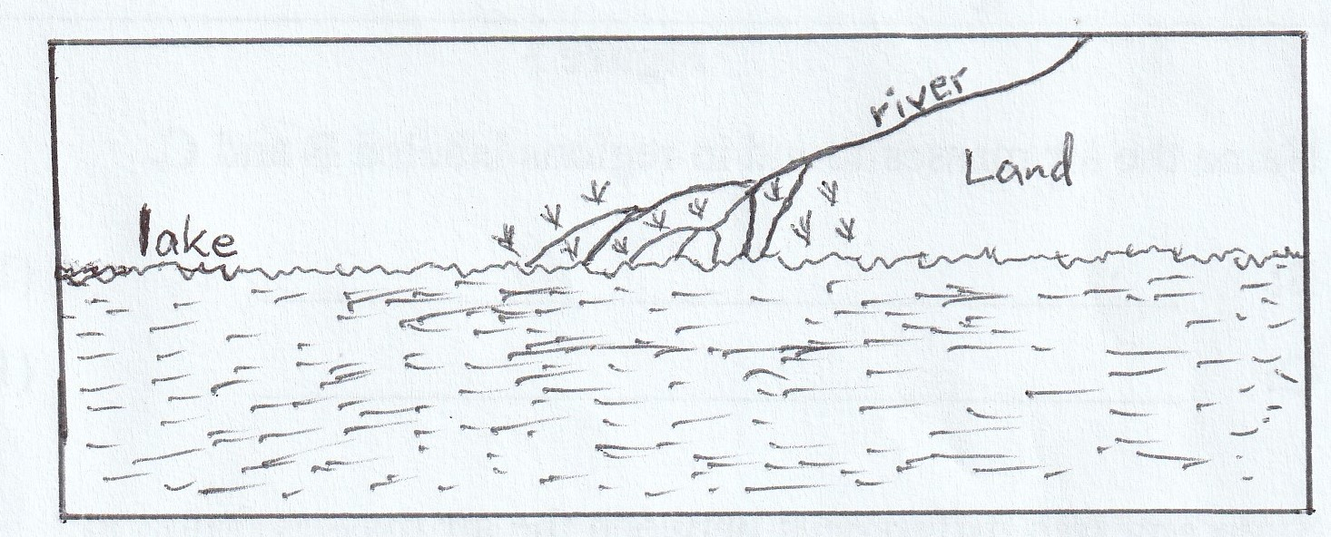

(i)Identify the feature in the figure.
_______________________________________________________________(1 mark)
(ii) Give any two conditions necessary for the formation of the feature.
_______________________________________________________________________________________________________________________________________________________________________________________________________________________________________________________________________________ (2 marks)
(iii)Name one example of the feature in Africa. ______________________________________________________________ (1 mark)
3. a. With aid of well labeled diagrams, explain how rift valleys are formed by tensional force.

_________________________________________________________________________________________________________________________________________________________________________________________________________________________________________________________________________________________________________________________________________________________________________________________________________________________________________________________________________________________________ (7 marks)
continued/…

b. (i) Explain any two ways of conserving wild life in Malawi. __________________________________________________________________________________________________________________________________________________________________________________________________________________________________________________________________________________________ (4 marks)
(ii)Give any two wildlife reserves in Malawi. ___________________________________________________________________________________________________________________________________ (2 marks)
c. Explain how good agricultural practices control each of the following
types of pollution:
- land pollution.
___________________________________________________________________________________________________________________________________ (2 marks)
- water pollution.
___________________________________________________________________________________________________________________________________ (2 marks)
d. Explain any one process of desertification. _______________________________________________________________________________________________________________________________________________________________________________________________________________________________________________________________________________________________________(4 marks)
e (i) Explain any one way how people adapt to climate change. __________________________________________________________________________________________________________________________________________________________________________________________________________________________ (2 marks)
(ii) Give any two human activities which promote climate change.
_______________________________________________________________________________________________________________________________________________(2 marks)

Section B (25 marks)
Answer any one question in this section
- a. Figure 3 is a diagram of a local wind. Use it to answer questions that follow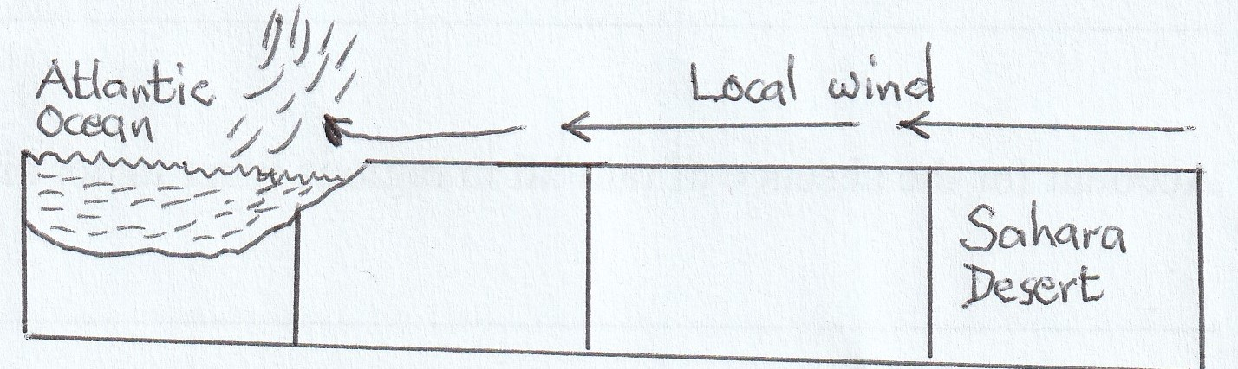

continued/…

- Identify the local wind.
_______________________________________________________________ (1 mark)
- Give any three characteristics of the local wind.
_____________________________________________________________________________________________________________________________________________________________________________________________________________(3 marks)
- Explain any two positive influences of the wind in the region it blows.
___________________________________________________________________________________________________________________________________________________________________________________________________________________________________________________________________________________(4 marks)
- Name any two countries that are affected by the local wind in the figure. _____________________________________________________________________________________________________________________________________ (2 marks)
b. With aid of a diagram, explain the occurrence of a warm front

_____________________________________________________________________________________________________________________________________________ ______________________________________________________________________________________________________________________________________ (5 marks)
c. (i) State any two characteristics of convection rainfall. ______________________________________________________________________________________________________________________________________ (2 marks) (ii) Give any two forms of precipitation that falls from cumulonimbus cloud only.
______________________________________________________________________________________________________________________________________ (2 marks)
d. The table below show a type of climate. Use it to answer questions that follow.
Month | J | F | M | A | M | J | J | A | S | O | N | D
Temp ℃ | 15 | 15 | 15 | 14 | 14 | 14 | 15 | 15 | 15 | 14 | 15 | 15
Rain(mm) | 170 | 170 | 236 | 279 | 216 | 127 | 104 | 157 | 185 | 274 | 257 | 231
- Identify the climate shown in the figure.
________________________________________________________________ (1 mark)

- At what altitude has the climate data been taken?
_______________________________________________________________ (1 mark)
- Give reason for your answer in 4d(ii) above.
_______________________________________________________________ (1 mark)
________________________________________________________________
- State any two factors that retard development in the region the climate is found.
________________________________________________________________
________________________________________________________________
________________________________________________________________ (2 marks)
continued/…
- Name any one country in Africa where the climate is experienced
_________________________________________________
(1 mark)
- a. Figure 4 is a map of the world showing prevailing winds. Use it
to answer questions that follow.

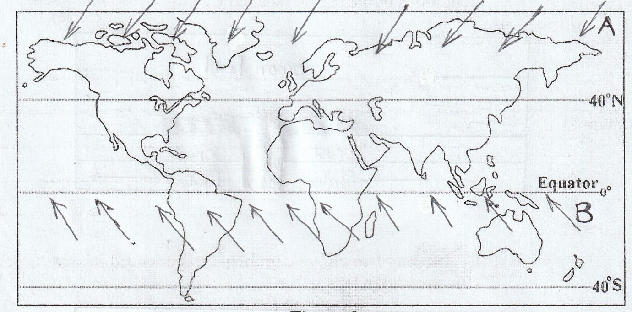

- Identify the prevailing winds marked A and B
A : ______________________________________________________ (1 mark)
B : _____________________________________________________ (1mark)
- Give any two characteristics of wind marked A
__________________________________________________________________________________________________________________________ (2 marks)
- Explain why wind A is well developed in southern hemisphere than in the northern hemisphere
__________________________________________________________________________________________________________________________ (2 marks)
- Explain the effect of wind B on the following regions:
- east of South America
__________________________________________________________________________________________________________________________(2 marks)
- south west of Africa
__________________________________________________________________________________________________________________________(2 marks)
b. Describe the weather associated with each of the following
air masses.
- Continental Tropical air mass (cT)
__________________________________________________________________________________________________________________________(2 marks)

continued/…

- Maritime Polar airmass (mP)
______________________________________________________________________________________________________________________________________(2 marks)
c. With aid of a well labeled diagram, explain how cyclonic rainfall occurs.

_______________________________________________________________________
______________________________________________________________________________________________________________________________________________ ______________________________________________________________________________________________________________________________________(5 marks)

d. Figure 5 below is a vegetation photograph. Use it to answer questions that follow:
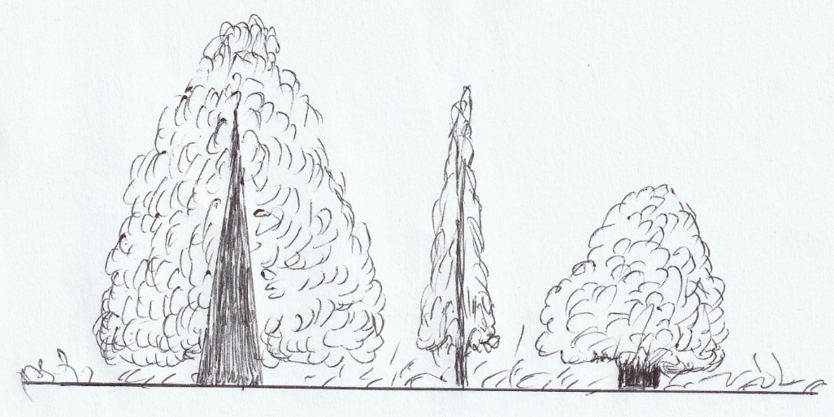

Figure 5
- Identify the type of vegetation shown in the figure.
__________________________________________________ (1 mark)
- In which climate is the vegetation found.
__________________________________________________(1 mark)
- State any two characteristics of the vegetation in the figure.
________________________________________________________________________________________________________________________________________________________________________________________________________________________________ (2 marks)
- Describe any one problem that affect growth of the vegetation in the region it is found
____________________________________________________________________________________________________________ (2 marks)

END OF QUESTION PAPER
NB: This paper contains 9 printed pages

